**Career Objectives**

To work in an environment where there is an opportunity of self-assessment and self-improvement in both individual and group based work that will ultimately lead to further development of the common people.

**Academic Qualification**

**B.B.A(Honors)**

Institute : Adarsha College, Dinajpur

Subject : Marketing

Passing Year : 2017

Result : 3.32

**H.S.C(Higher Secondary Certificate)**

Institute : Minul Hasan Degree College

Subject : Commerce

Passing Year : 2013

Result : 3.50

**S.S.C(Secondary School Certificate)**

Institute : Utter Madhabpur High School

Subject : Science

Passing Year : 2011

Result : 4.44

**Training**

1. One year professional diploma couse in Java Programming form IDB-BISEW.

2. Six month diploma course in Electrical House Wearing form Technical Training Center (TTC)

**Skills**

**Languages : Java, JSP**

**Web Design : Html5, CSS, Bootstrap 4, JavaScript, Angular**

**Database : MySQL, Oracle**

**Frameworks: Spring MVC, JSF, Hibernate, Swing**

**Projects**

**1. Hospital Management System with Spring MVC**

**2. Medicine Shop Management System with Java Swing**

**3. Hospital Management System with Angular**

**4. Railway Online Ticket Booking with Bootstrap.**

**References**

**Signature**

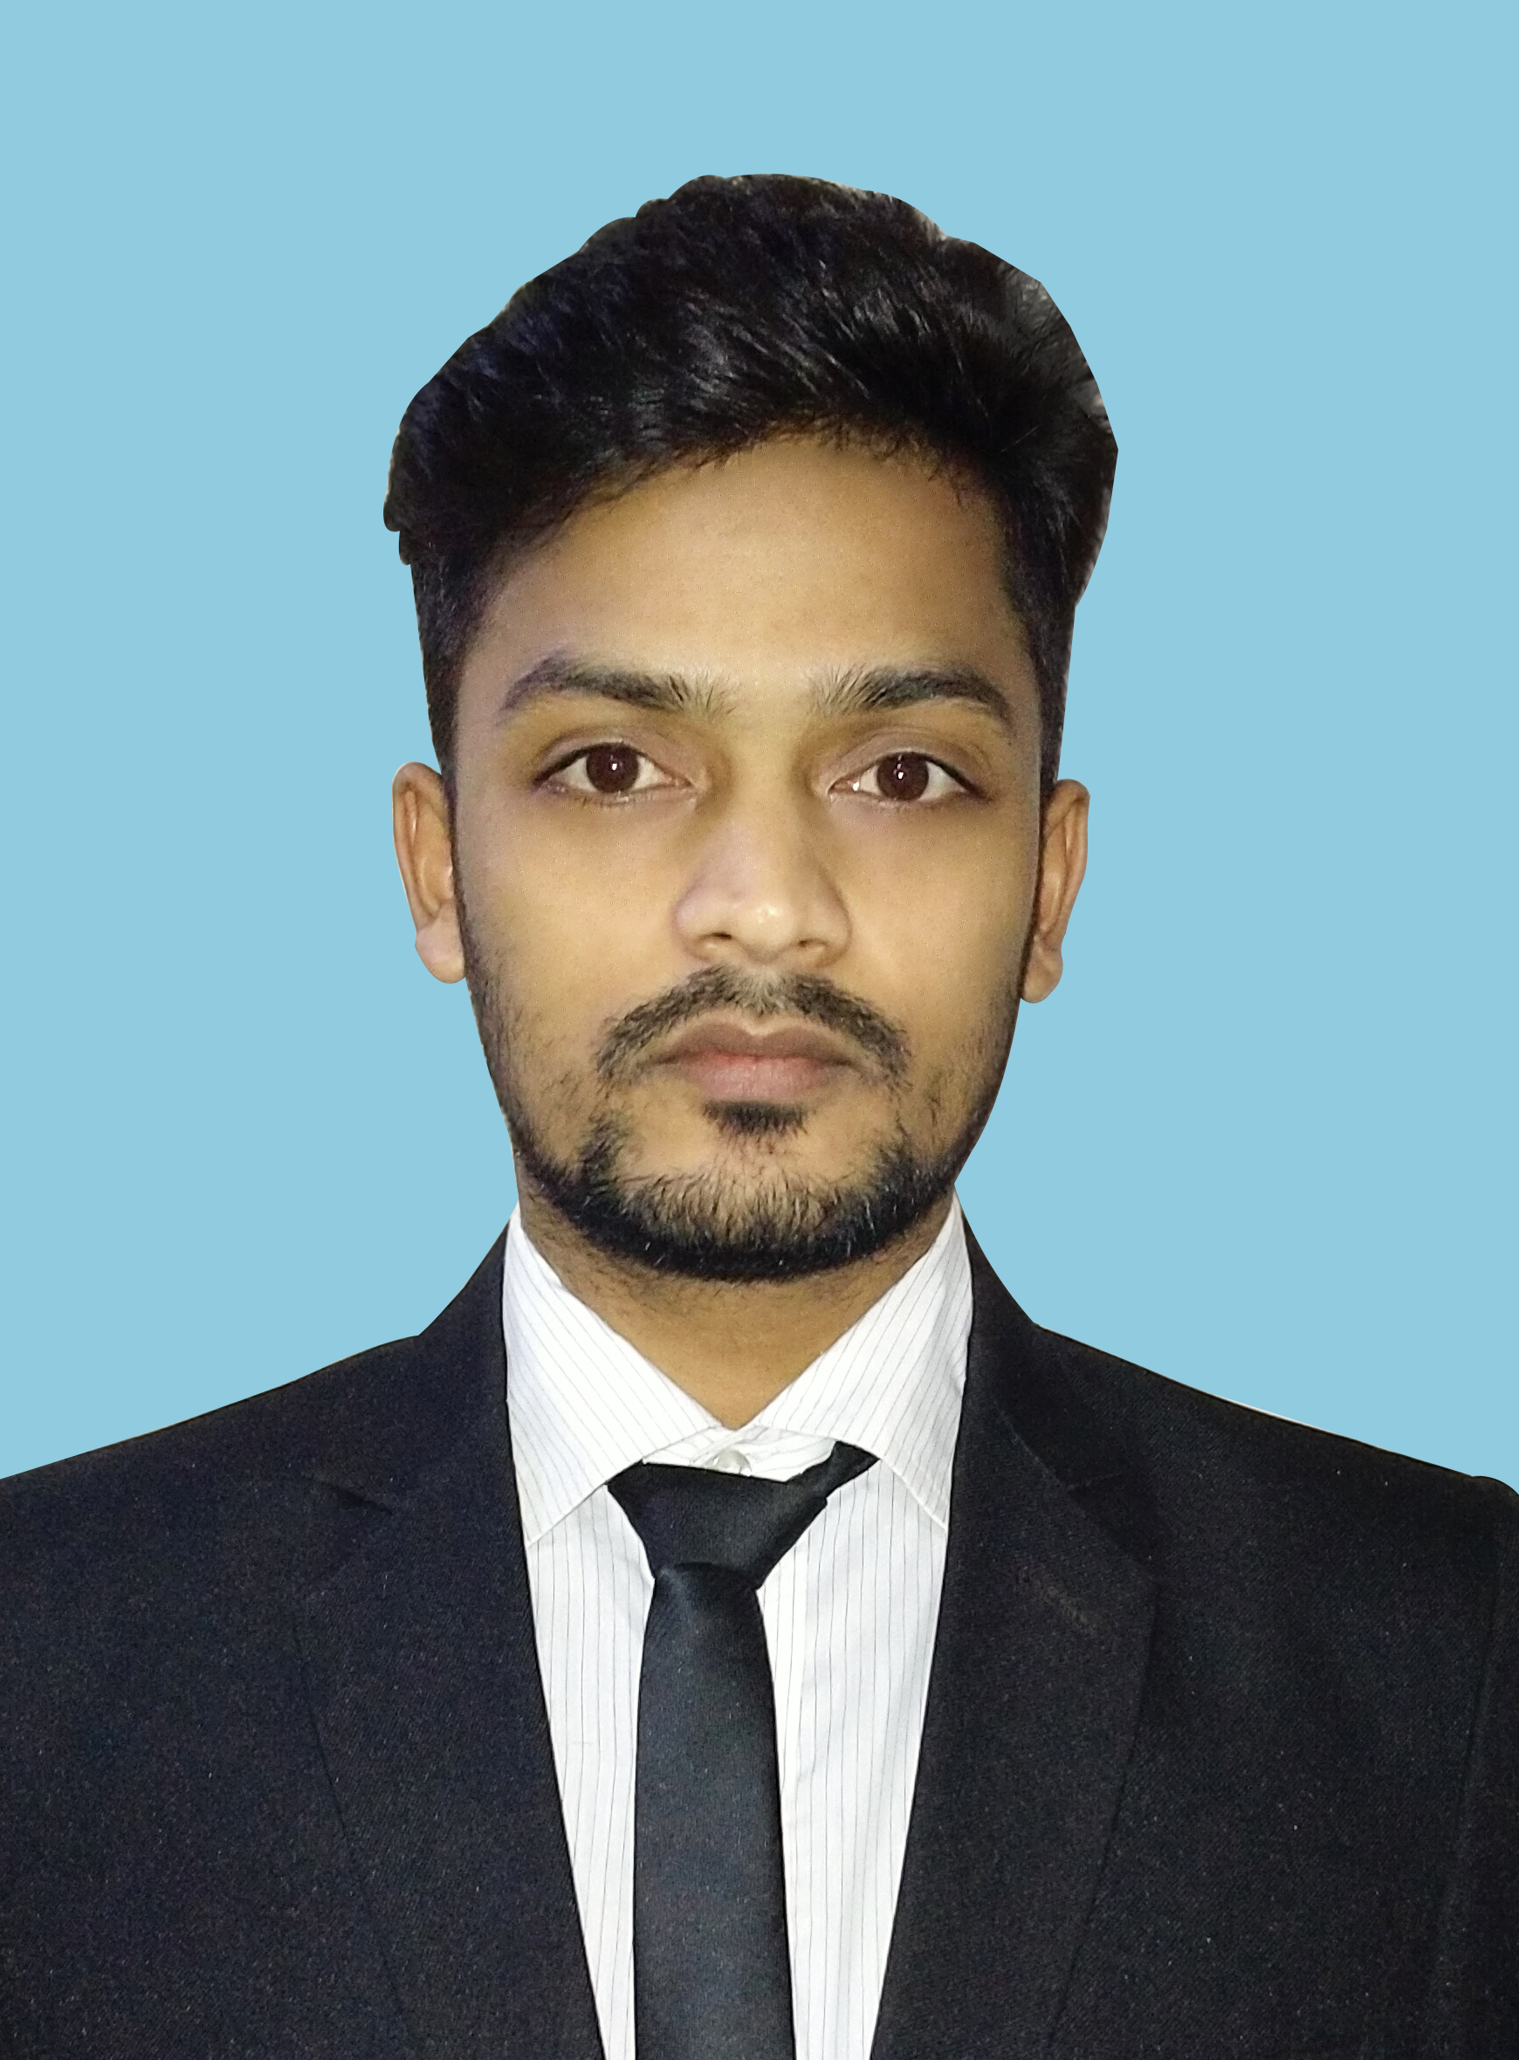

**MD. SIDDIKUR RAHMAN**

**Mailing Address**

**Address:**

196/3, Santibagh, Malibagh

Dhaka-1217

**Phone:**

01784988095

**Email:**

Siddiquerrahman95@gmail.com

**Personal Details**

Father’s Name : Md Altab Hossen

Mother’s Name : Saleha Begum

Nationality : Bangladeshi

Sex : Male

Marital Status : Single

Date of Birth : 07/09/1995

Religion : Islam

Blood Group : O+

Height : 5.9”

NID : 6888182778

**Permanent Address**

Utter Shampur

Singul-5210, Birol

Dinajpur

**Social Network**

Github: https://github.com/siddiquer/

LinkedIn:

https://www.linkedin.com/in/siddiquer-rahman-5035571a1/

